TEXTLINK 2nd Action Conference, Budapest
Participants’ form

-Last name:
-First name:
-E-mail address:

Conference participation:
Please indicate which conference events you will participate in:
- MC meeting (Monday)
- Conference (Tuesday – Wednesday)
- WG2/3 workshop (Wednesday/Thursday)

Lunches:
Please indicate which days you will join for lunch:
- Monday
- Tuesday
- Wednesday

Social program
Monday, 11 April | Tuesday, 12 April *** | Wednesday, 13 April ***
Social Dinner  (included in reg. fee)  yes/no | Dinner Cruise on the Danube*  35€ yes/no | Concert  Budapest Spring Festival, Brandenburg project  ticket prices (acc. to closeness to stage):  4€ number of tickets:  8€ number of tickets:  12€ number of tickets:
* Please note that this discount price might change somewhat as a function of the number of participants.
*** the fee for these events is payable when you pay your registration fee

Please indicate your special dietary requirements (relevant lunches, so please fill in even if you don’t participate in the social programs):
- vegetarian
- vegan
- diabetic
- glutenfree
- dairyfree

1, Conference Dinner
time: Monday, 11 April, 7 p.m.
venue: TBA

2, River Cruise on the Danube with dinner
time: Tuesday, 12 April, 8 p.m.

private 2-hour-long river cruise on the Danube
including: buffet dinner - welcome champagne - 1 glass of soft drink or beer or mineral water / coffee / tea

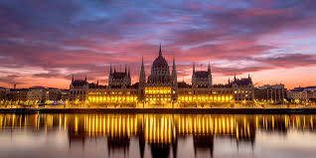

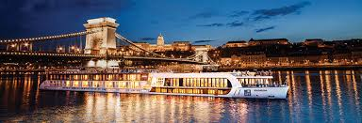

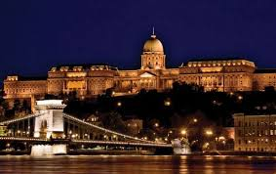

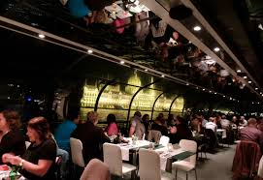

3, Concert:
time: Wednesday, 13 April, 7.30 p.m.
venue: Liszt Academy of Music, Concert Centre
Budapest, Liszt Ferenc tér 8.

programme:
Budapest Spring Festival: Brandenburg-Project
J. S. Bach

Please send this form to nicola.thrupp@uclouvain.be by 20th February, 2016!!!! Thank you!

